Name: **Vipul Pradeep Chaudhari**

Employee Id: **1008825**

SQL Query:

* ***Create database***

create database jpa;

* ***use database***

use jpa;

* ***Create Table Customer***

CREATE TABLE Customer (

id BIGINT PRIMARY KEY AUTO_INCREMENT,

name VARCHAR(15) NOT NULL,

balance DOUBLE NOT NULL

);

* ***Create Table CreatedOrder***

CREATE TABLE CreatedOrder (

id BIGINT PRIMARY KEY AUTO_INCREMENT,

customer_id BIGINT,

creationDateTimeMillis BIGINT,

amount DOUBLE,

productInfo VARCHAR(255),

FOREIGN KEY (customer_id) REFERENCES Customer(id)

);

* ***Table Customer***

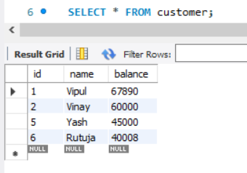

* ***Table Createorder***

